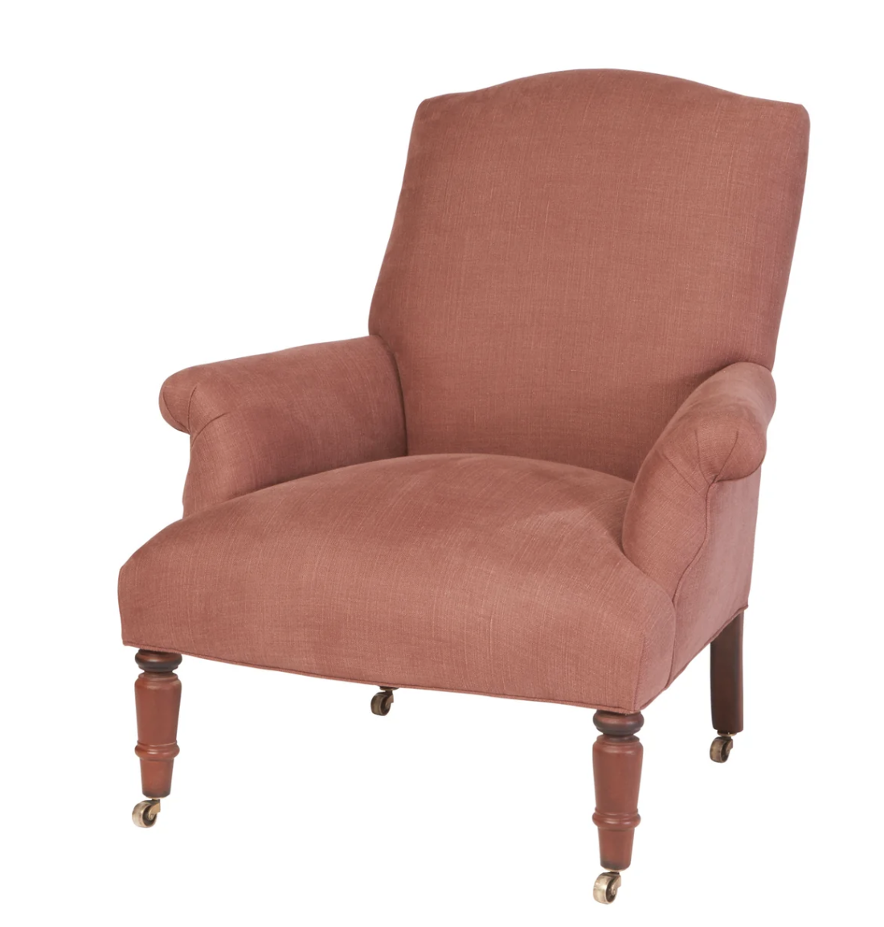
Fritillaria Chair

Overall Dimensions: 32” W x 34” D x 37” H
Seat Height: 17”

DETAILS:

HAMMERTOWN PRICE:

*Price Subject to Change*
*available in other fabrics by special order; fabric & customizations determine price*

